Mueller Laboratory Renovation:
Problem Identification and Technical Analysis Options Summary Report

By
Mark Jackson
Construction Management Option
12/5/14

Introduction
The Mueller building renovation is relatively straightforward. There are no significant constructability challenges. However the project is located on the busy PSU campus. Any ways to minimize the project’s duration, its impact on its surroundings, occupants and the environment, and the overall cost, should be investigated fully. This report examines five ways that these goals can be pursued.

Recycling
The Mueller building renovation includes significant gutting of four floors of the building. This demolition will create a large amount of construction waste, which could just be thrown in dumpsters and hauled away. However, Penn State seeks to be as sustainably minded as possible. Penn State currently diverts 60% of its waste from landfills by recycling and composting as much as possible. For all construction work Penn State requires the recycling or reuse of 75% of project waste. The following materials Section 8.11 of Penn State’s general conditions for construction contracts states that “The contractor is required to recycle and/or salvage 75% of construction, demolition, and land clearing waste.” To that end, Penn State specifically seeks to recycle or reuse the following materials:

•Cardboard
•Clean dimensional wood
•Beverage and food containers
•Brick and CMU
•Ferrous and non-ferrous metals
•Recyclable Plastic
•Gypsum wallboard
•Asphalt and concrete paving
•Ceiling Tile
•Carpeting
•Existing Windows
•Used equipment oil
•Useable appliances

This construction waste recycling plan is required regardless of whether the project is a LEED project or not.
A more detailed analysis of the specific recycling possibilities of the Mueller renovation is definitely warranted. Planning, scope, and implementation of recycling all could be studied. More or less recycling on the project could affect project schedule, as well as project cost.

Asbestos Abatement
In addition to general project waste, the Mueller renovation includes asbestos abatement on 4 of the building’s 7 floors. On the schedule this abatement takes from five to fifteen days for each floor, adding up to forty days of schedule time. Reasons for pursuing the abatement should be considered, especially since the three un-renovated floors of the building will still have asbestos at the conclusion of the project. If abatement is necessary methods to speed up the process should be examined. Additional manpower or longer workdays will shorten the schedule, but will have an effect on the project cost. This too can be analyzed.

Roof Deck Reinforcement
Early in the project the roof deck is scheduled to be reinforced from underneath to allow the new heavy air handling units to be placed on the roof deck. This reinforcement requires the demolition on the sixth floor to be complete. Investigating other ways to reinforce the roof deck, or alternate locations for the air handling units that would not require roof deck reinforcement, could prove valuable. If a solution is found that does not require roof deck reinforcement then the placement of the AHUs is no longer dependent on the completion of the sixth floor demolition. This would lead to both schedule and cost savings. However, if reinforcement is required, prefabrication of the reinforcement components could also save schedule time. Either way, further investigation is warranted.

Site grading
From the north side of the Mueller Building to the south side the ground drops roughly 15 feet over a 150 foot run. This ten percent grade carries rainwater off the site to even steeper slopes south of the building, as seen in the topographic map below.
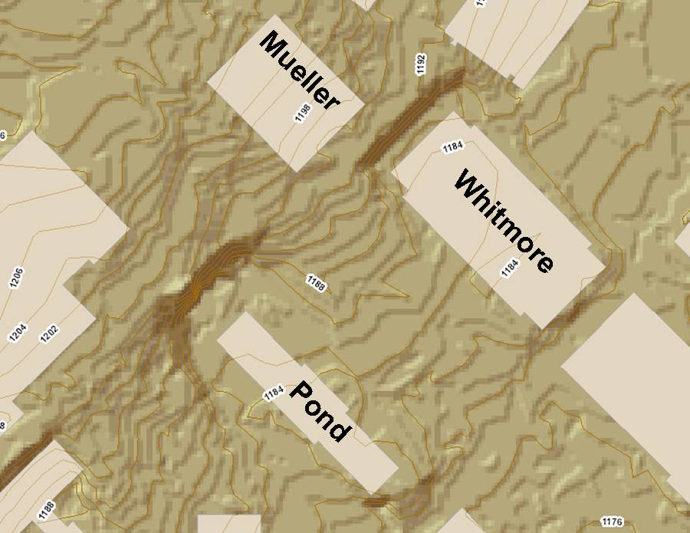
Figure 1. Red lines represent 2 ft contours.
Without proper prevention sediment and other contaminants could run off the site and into storm drains, contaminating a wide area. While placement of silt socks around the side would control sediment, other options should be investigated. Re-grading of the site or installation of runoff catch basins could mitigate contamination problems. It is also important to consider that both these options would have impact on the existing trees and other surrounding landscaping. Minimizing disturbance to Penn State’s campus, which acts as an arboretum, is a necessary concern. Also, extra work in grading the site will increase both the project cost and duration.

Site Access
The access road to the Mueller Building renovation branches off from the PSU Library loading dock. While this road location is convenient and easy, it does necessitate the rerouting of students away from the walkways surrounding Mueller Building, including the installation of a temporary sidewalk. Also construction debris on trucks can easily enter the Library driveway and nearby Curtain road. Alternate locations for the site access road, including from the south, should be considered, as shown below.
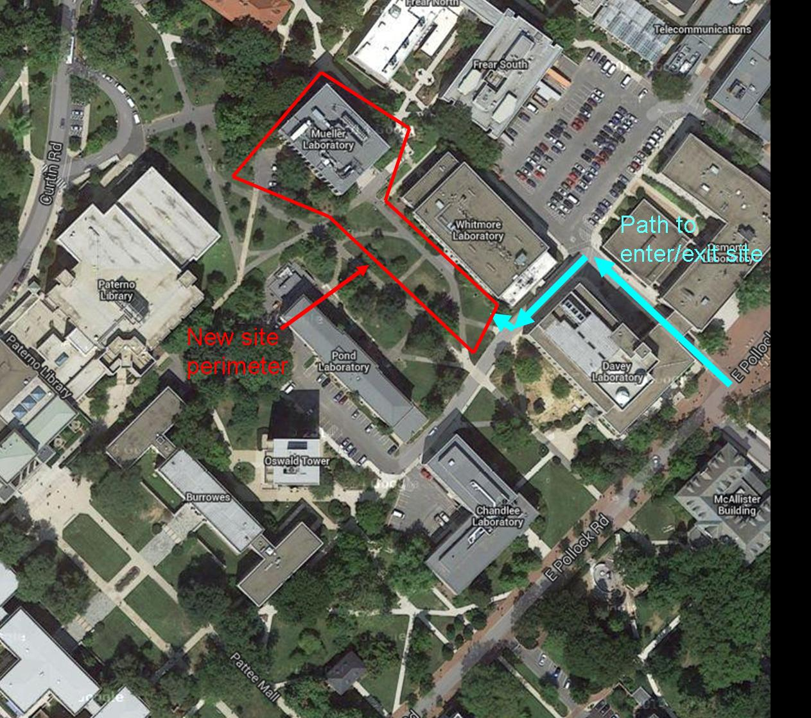
Figure 2. New site perimeter and entrance.
The large area between Whitmore and Pond laboratories could serve as an access road, with room for contractor parking and material storage. However, this would impact the two buildings noted above. Also, there are several trees in the space, as are next to the Mueller building. Minimizing impact on them, as noted in the previous paragraph, would be necessary. The advantage of this area is it contains a redundant sidewalk, such that with careful planning the north-south pedestrian traffic could remain unimpeded. This area also could contain a truck-wash station if desired. Further study of this possibility needs to be undertaken.

Conclusion
All of these alternate construction options deserve further investigation. The degree to which recycling and asbestos abatement is pursued will have an effect on both project schedule and cost. Finding an option where roof reinforcement is unnecessary would also cut costs and schedule duration. And examining other possible project parking and delivery areas affect both the project’s impact on its community and the environment. Studying each of these options more will quickly show which are not viable and which do have potential to reduce cost, duration, and impact on the building’s environment.

